FICHE META_INFORMATION_PARAMETRES
(à remplir par le responsable du paramètre)

( A renseigner PENDANT la mission )

PARAMETRES CONCERNES / Parameters

98323: Concentration of Dissolved Rare Earth Elements (<0.4 μm)

OPERATION & CAMPAGNE / OPERATION & CAMPAIN
Nom de l’opération: « normal CTD (label PN) »
Station number-Cast number : see the table below

Measurements of the dissolved (<0.4 μm) Rare Earth Elements (REE: La, Ce, Pr, Nd, Sm, Eu, Gd, Tb, Dy, Ho, Er, Tm, Yb, Lu) in the water column.

Nom de la campagne: PANDORA, (R/V Atalante, June 27th-Aug 6th, 2012)

PROJET ETUDE / PROJECT TITLE

THE PANDORA CRUISE, JULY 2012: AN INTEGRATED APPROACH OF THE CIRCULATION AND GEOCHEMISTRY IN THE SOLOMON SEA
PIs: Alexandre Ganachaud, Sophie Cravatte, Catherine Jeandel
Chief Scientist: Gérard Eldin
Tracing water mass pathways and boundary exchanges with neodymium isotopes and REE concentrations in the Solomon Sea and at its entrances/exits

RESPONSABLE SCIENTIFIQUE / PRINCIPAL INVESTIGATOR

Nom /  name | adresse /  address | téléphone / phone number | fax /  fax number | adresse mél /  email address
Catherine Jeandel | GEOMAR, LEGOS, Toulouse | +33.5.61.33.29.33 | +33.5.61.25.32.05 | Catherine.Jeandel@legos.obs-mip.fr
Mélanie Grenier | GEOMAR, LEGOS, Toulouse | +33.5.61.33.28.47 | +33.5.61.25.32.05 | melanie.grenier@legos.obs-mip.fr

BREVE DESCRIPTION DU PROJET / BRIEF DESCRIPTION OF PROJECT

When flowing in the South-West Pacific and through the Solomon Sea, water masses undergo dynamical transformations as well as nutrients and micronutrients enrichments when entering in contact with the coasts of the Western Pacific. This impacts the productivity of the Equatorial Pacific Cold Tongue and therefore its climatic role. Trace elements that are injected from this “boundary processes” provide key information on mixing processes. Establishing the distribution of these elements and quantifying these land/ocean inputs is a priority of the international GEOTRACES program. Gaining a better knowledge of water mass transformations and pathways through the South-West Pacific is a priority of SPICE program (South Pacific Circulation and Climate Experiment).
In the frame of SPICE and GEOTRACES, the SOLWARA project focuses on these mechanisms in the Solomon Sea area, one of the key regions for the above mentioned surface and sub-surface water masses. This project includes historical physical and geochemical data analysis, deployment of autonomous observing platforms in the South-West Pacific, modelling, and the PANDORA oceanographic cruise with specific objectives and strategy. PANDORA is labelled as the GP12 GEOTRACES section (www.geotraces.org). The main objectives of the cruise are: to provide a quasi-synoptic description of surface and subsurface circulation in the Solomon Sea and in the straits connecting that sea with the equatorial circulation based on both hydrological and geochemical parameters; to deploy a series of moorings in the straits to obtain the temporal variability of the circulation; to evaluate water masses transformations and mixing; to document water/margins exchanges. The experimental approach will combine physical, chemical and geochemical experiments, which will give access to a wide range of space and time scales of the circulation and biogeochemical processes.

DESCRIPTION DES PARAMETRES / PARAMETERS DESCRIPTION

Ce qui a été mesuré et comment / What did you measure and how did you do it (include references for analytical methods)?

dREE concentrations were determined using the LEGOS protocol (Lacan and Jeandel, 2001; Tachikawa et al., 1999). Briefly, dREEs were extracted from the seawater aliquot by a co-precipitation with iron hydroxides, followed by purification through ion-exchange column and measured with a High Resolution Inductively Coupled Plasma Mass Spectrometer (HR-ICP-MS). In details, a trispike solution containing ¹⁵⁰Nd (97.84%), ¹⁵³Eu (97.84%), and ¹⁷⁴Yb (94.9%) was added to the acidified seawater aliquots of 250 mL or 500 mL. Approximately 2.5 mg of purified FeCl3 diluted in 0.1M HCl was then added to the samples. The homogenization was ensured by a continuous shaking of the sample during 24h and a subsequent 24h resting state before performing the co-precipitation. Then, the pH was increased to 8±0.5 by adding suprapur NH4OH yielding the iron hydroxides to co-precipitate the dREEs. The dREEs-Fe precipitate was then rinsed and separated from the seawater by successive centrifugations. This rinsing step was repeated between 5 to 7 times and the precipitate was later dissolved in 1 mL of 6M HCl and then loaded on an anion exchange column packed with 2 mL of AG1-X8 resin, in order to purify the dREE fraction from Fe. dREEs were then eluted from the column using 4 mL of 6M HCl and evaporated to dryness. Finally, the residue was dissolved again with 5 mL HNO3 0.32M spiked with an internal standard (In-Re, 100 ppt), which is the appropriate solution to measure the concentrations on a sector field Inductively Coupled Plasma Mass Spectrometer (THERMO ELEMENT XR™ ICP-MS).
Recoveries of the whole experiment (including sensitivity variations during the ICP-MS sequence) were precisely determined by comparing the Nd, Eu and Yb concentrations calculated by Isotopic Dilution (ID-CONC) with that measured by external calibration (EXT-CONC). The ratio (EXT-CONC)/(ID-CONC) for these 3 elements were then linearly interpolated and extrapolated to be applied to the remaining dREE concentrations, measured by external calibration only. On the average, recoveries of more than 80% were obtained for the light REEs, and around 77% for the middle and heavy REEs. Our method based on 2 or 3 spikes followed by an interpolation was validated by comparing results obtained using 10 spikes on the same seawater samples, either in the framework of T. Rousseau thesis (Rousseau et al., 2013) or in the recent work of M. Behrens (Behrens et al., 2016). During the ICP-MS analysis, the use of a desolvating nebulizer system (ARIDUS II) considerably minimized the oxide interference formation (Chung et al., 2009; Grenier et al., 2013; Pahnke et al., 2012). This is notably effective for the barium oxide formation reduction, which subsequently improves the analytical accuracy for 151Eu and 153Eu.

Stratégie d'échantillonnage / Sampling strategy (include a map of the sampling location)
Seawater samples were taken at the depths of the following stations:

Décrire quels types de données sont nécessaires pour compléter votre propre jeu de données avant envoi à la base de données, et estimez le délai avant la disponibilité de vos données pour la base de données / Post-cruise data analysis/treatment required, and the time frame for this

Ancillary hydrographic parameters, tracer measurements on particles (filtered on 47mm Supor membranes or ISP filters when done).
Public access will be open after acceptance of the papers in preparation.

Estimations des erreurs, précision, sensibilité des données / Error estimates, precision and accuracy of the data

Replicate measurements were conducted on filtered (4 replicates, station 73, 1650 m) and non-filtered samples (3 replicates at 1650 m of station 73 and 4 replicates at 1200 m of station 82). Filtered light REE (dLREEs) concentrations agree within 8% for La, 14% for Ce and 4% for Pr and Nd; filtered middle (dMREEs) and heavy (dHREEs) concentrations agree within 8% for Sm, 11% for Eu and less than 4% for the remaining REEs. Non-filtered concentrations are agreeing within less than 4% for all the LREEs (including Ce) and 7% for MREEs and HREEs
The average chemical blank values were established on 20 measurements. Blank levels represent less than 2% of the LREE signals and less than 0.7% for MREE and HREE ones. Due to the very low Ce concentrations in our samples, the dCe blanks represent 14±9% of the sample signal. In addition, the blank of our on-board filtration system was checked by filtering twice the same samples. No noticeable variation of concentration was observed, assessing the cleanliness of our systems. Finally, our full dREE analytical procedure was validated by our successful participation to two GEOTRACES intercalibration exercises (Behrens et al., 2016; van de Flierdt et al., 2012).
In addition, our data were compared with other studies for its validation. Two previous studies analyzed samples outside the Solomon Sea and in the Coral Sea (Grenier et al., 2013; Zhang and Nozaki, 1996), allowing us to compare our data with published values. The following figure shows the locations of these stations and the dREE concentrations versus potential density in order to compare the dREE values in the same isopycnal layers. This following figure highlights the excellent agreement between our data and these previous results. The minor difference observed between the surface dLa concentrations at SA-7 and at station 82 of our study likely reflects the dissimilarity in our sampling locations and times of the year, in this region of high eddy variability (Keppler et al., 2018).
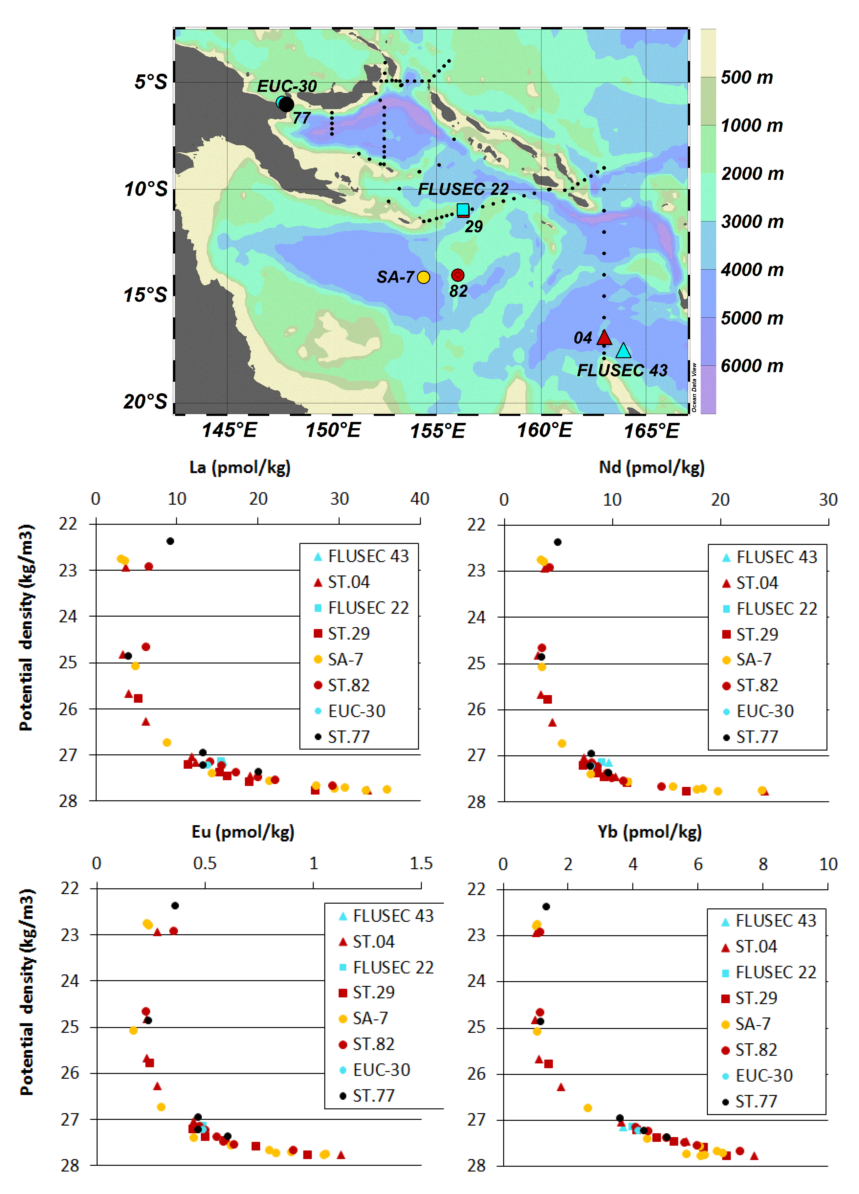
For the GEOTRACE intercalibration, our data of station PN042 are also validated when giving the good comparison with the sample from CA63 station of Casseopee cruise in 2014. It is noted that there are still some different points between two of cruise. The different sampling period between the two cruise could lead to the variation in the result.

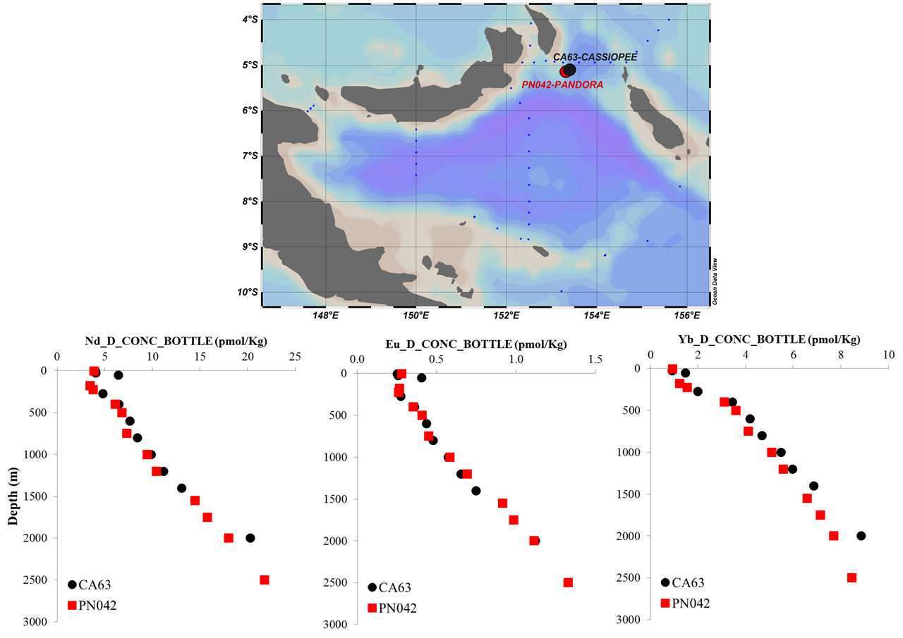

FICHIERS / FILES

Nom de fichier de données / file name
The file “dissolved_REE.xls” reports the dissolved REE concentrations at each depth for each station. Units are in pmol/kg

Explication des têtes de colonne, des unités et des abréviations utilisées dans le fichier de données / data file structure

REE concentrations are given in “pmol/kg”
Longitudes and latitudes are given as decimal numbers.
nd : not determined

REFERENCES BIBLIOGRAPHIQUES

Lacan F and Jeandel C., 2001. Tracing Papua New Guinea imprint on the central Equatorial Pacific Ocean using neodymium isotopic compositions and Rare Earth Element patterns. Earth Planet. Sci. Lett. 186, 497-512.

Tachikawa K., Jeandel C. and Roy-Barman M., 1999. A new approach to the Nd residence time in the ocean: the role of atmospheric inputs. Earth Planet. Sci. Lett. 170, 433-446.

