FICHE META_INFORMATION_PARAMETRES
(à remplir par le responsable du paramètre)

PARAMETRES CONCERNES / Parameters

Dissolved Zinc by micro-Sequential Injection Analysis
Parameter code: will be attributed later by the data base

OPERATION & CAMPAGNE / OPERATION & CAMPAIN
Nom de l’opération (moyen de prélèvement/sampling tool): « clean rosette (label PP) »

Station number-Cast number: see the compilation in the table below

Nom de la campagne/name of the cruise: PANDORA, (R/V Atalante, June 27th-Aug 7th, 2012)

PROJET ETUDE &PIs / PROJECT TITLE&PIs

THE PANDORA CRUISE, JULY 2012: AN INTEGRATED APPROACH OF THE CIRCULATION AND GEOCHEMISTRY IN THE SOLOMON SEA
PIs: Alexandre Ganachaud, Sophie Cravatte, Catherine Jeandel
Chief Scientist: Gérard Eldin (gerard.eldin@legos.obs-mip.fr)
All at LEGOS, Observatoire Midi-Pyrénées, Toulouse, Fr and IRD Center, Nouméa, NC

RESPONSABLE SCIENTIFIQUE du paramètre / PI of the parameter

Nom /  name | adresse /  address | téléphone / phone number | fax /  fax number | adresse mél /  email address
M. Grand | Univ. Hawaii. Dept of Ocenography, USA | +1-808-554-1501 | +1 808 956 7112 | maxime@hawaii.edu

BREVE DESCRIPTION DU PROJET / BRIEF DESCRIPTION OF PROJECT

DESCRIPTION DES PARAMETRES / PARAMETERS DESCRIPTION

Ce qui a été collecté, mesuré et comment / How was the parameter collected and measured (include references for analytical methods)?

Sampling: Seawater samples were taken with 12, 12L GO-FLO bottles mounted on a clean rosette deployed on a 1350m long conducting Kevlar line. Details of the clean sampling system and protocol can be found in Measures et al. (2008, L&O Methods, 6: 384-394). The rosette was fitted with a SBE 9Plus CTD with pressure, temperature, conductivity, and dissolved oxygen sensors and an uncalibrated fluorometer (WetLabs). A SBE 32 water sampler was used to trip the bottles. The CTD main housing and sensors are all made of aluminium and housed in a protective stainless steel cage.
Bottles were fired on the fly during the upcast while slowing down but not stopping the upward motion of the rosette. The entire sampling device (rosette, bottles, sensors and winch) was lent by Chris Measures from University of Hawaii (USA). Before taking the first samples the GO-FLO were filled with surface seawater for 48h. Immediately after recovery, the GO-FLO were carried into a clean container pressurized with filtered air (ISO class 8, lent by DT INSU, Brest, France).

Filtered: The GO FLO were pressurized with 0.5 bar high quality nitrogen filtered through 0.2µm pore size PTFE Acrovent capsule filters at entrance to each sampling bottle. The seawater was filtered through 0.2µm pore size cellulose acetate Sartobran 300 capsule filters connected to the GO FLO with an acid cleaned PVC tubing. Before first use the capsules were rinsed with 10L surface seawater. Then before each new sample with 240 ml of that sample. The vial and its cap were rinsed 3 times before being filled with the sample

Samples were acidified onboard to 24mM HCl with a 9.4M solution of double distilled HCl.

Analytical procedure (briefly, could be a short link to a published reference):
Samples were analyzed onboard using the method of Grand et al. (2011). However, since the limit of detection of this technique is too high for the upper 400m of the water column, all samples will be re-analyzed in the laboratory once a suitable pre-concentration technique compatible with micro-Sequential Injection has been developed.

Synthèse échantillons collectés / Compilation of the collected samples (add a map of the cruise if possible)
DZn
PP004 G0 | PP010 G1 | PP013 G2 | PP021 G2b | PP034 G3a | PP039 G4 | PP042 G8 | PP043 G5 | PP060 G9b | PP071 G11 | PP077 G13 | PP081 G14 | PP082 G15
50 | 1302 | 1300 | 1300 | 353 | 1300 | 1301 | 1302 | 1300 | 1300 | 999 | 400 | 1298
448 | 1300 | 1000 | 1000 | 249 | 998 | 1001 | 1002 | 1150 | 1000 | 902 | 300 | 1000
449 | 1001 | 700 | 700 | 181 | 700 | 700 | 700 | 1000 | 860 | 801 | 225 | 800
620 | 701 | 500 | 503 | 130 | 500 | 501 | 500 | 850 | 730 | 701 | 180 | 651
620 | 502 | 400 | 401 | 80 | 225 | 401 | 400 | 700 | 550 | 599 | 140 | 447
780 | 500 | 300 | 303 | 46 | 398 | 297 | 160 | 500 | 399 | 501 | 90 | 300
780 | 399 | 225 | 203 |  | 295 | 226 | 300 | 400 | 299 | 398 | 30 | 224
1000 | 397 | 181 | 199 |  | 226 | 186 | 300 | 294 | 200 | 299 |  | 175
1000 | 300 | 180 | 140 |  | 164 | 127 | 225 | 220 | 170 | 220 |  | 135
1300 | 223 | 125 | 89 |  | 110 | 130 | 91 | 177 | 118 | 174 |  | 80
1320 | 175 | 74 | 45 |  | 64 | 85 | 55 | 129 | 69 | 141 |  | 24
18 | 135 | 34 | 26 |  | 27 | 25 | 25 | 65 | 23 | 82
20 | 95 |  |  |  |  |  |  | 29 |  | 75
49 | 30 |  |  |  |  |  |  | 23 |  | 25
50
88
90
138
140
198
200
298
300
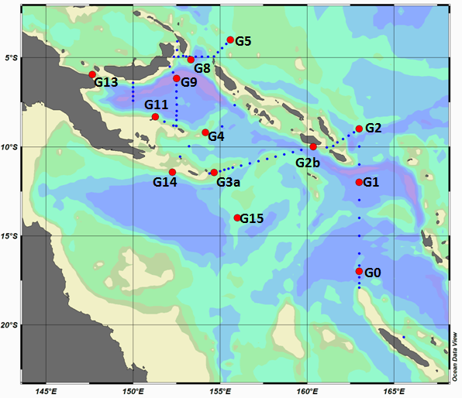

Décrire quels types de données sont nécessaires pour vous compléter votre propre jeu de données avant envoi à la base de données, et estimer le délai avant la disponibilité de vos données pour la base de données / Post-cruise data analysis/treatment required, and the time frame for this

Further method development is needed to lower limit of detection of method used onboard. Estimated time frame: ~36 months.

Estimations des erreurs, précision, sensibilité des données / Error estimates, precision and accuracy of the data

To be filled up when then measurements will be done

FICHIERS / FILES (that will be sent to the data bas

Nom de fichier de données / file name

To be filled up when then measurements will be done

Explication des têtes de colonne, des unités et des abréviations utilisées dans le fichier de données / data file structure

To be filled up when then measurements will be done

REFERENCES BIBLIOGRAPHIQUES

Measures, C.I., W.M. Landing, M.T. Brown and Buck, C.S. (2008). A commercially available rosette system for trace metal clean sampling. Limnology and Oceanography: Methods. 6: 384-394

Grand, M., Oliveira, H.M., Ruzicka, J., Measures, C., 2011. Determination of dissolved zinc in seawater using micro-Sequential Injection lab-on-valve with fluorescence detection. Analyst 136, 2747-2755.

