FICHE META_INFORMATION_PARAMETRES
(à remplir par le responsable du paramètre)

PARAMETRES CONCERNES / Parameters
Dissolved Nickel

Parameter code: will be attributed later by the data base

OPERATION & CAMPAGNE / OPERATION & CAMPAIN
Nom de l’opération (moyen de prélèvement/sampling tool): « clean rosette (label PP) »

Station number-Cast number: see the compilation in the table below

Nom de la campagne/name of the cruise: PANDORA, (R/V Atalante, June 27th-Aug 7th, 2012)

PROJET ETUDE &PIs / PROJECT TITLE&PIs

THE PANDORA CRUISE, JULY 2012: AN INTEGRATED APPROACH OF THE CIRCULATION AND GEOCHEMISTRY IN THE SOLOMON SEA
PIs: Alexandre Ganachaud, Sophie Cravatte, Catherine Jeandel
Chief Scientist: Gérard Eldin (gerard.eldin@legos.obs-mip.fr)
All at LEGOS, Observatoire Midi-Pyrénées, Toulouse, Fr and IRD Center, Nouméa, NC

RESPONSABLE SCIENTIFIQUE du paramètre / PI of the parameter

Nom /  name | adresse /  address | téléphone / phone number | fax /  fax number | adresse mél /  email address
Sarthou | LEMAR Brest |  |  | Geraldine.Sarthou@univ-brest.fr
Bowie | ACE CRC |  |  | Andrew.bowie@utas.edu.au

BREVE DESCRIPTION DU PROJET / BRIEF DESCRIPTION OF PROJECT
When flowing in the South-West Pacific and through the Solomon Sea, water masses undergo dynamical transformations as well as nutrients and micronutrients enrichments when entering in contact with the coasts of the Western Pacific. This impacts the productivity of the Equatorial Pacific Cold Tongue and therefore its climatic role. Trace elements that are injected from this “boundary processes” provide key information on mixing processes. Establishing the distribution of these elements and quantifying these land/ocean inputs is a priority of the international GEOTRACES program. Gaining a better knowledge of water mass transformations and pathways through the South-West Pacific is a priority of SPICE program (South Pacific Circulation and Climate Experiment).
In the frame of SPICE and GEOTRACES, the SOLWARA project focuses on these mechanisms in the Solomon Sea area, one of the key regions for the above mentioned surface and sub-surface water masses. This project includes historical physical and geochemical data analysis, deployment of autonomous observing platforms in the South-West Pacific, modelling, and the PANDORA oceanographic cruise with specific objectives and strategy. PANDORA is labelled as the GP12 GEOTRACES section (www.geotraces.org). The main objectives of the cruise are: to provide a quasi-synoptic description of surface and subsurface circulation in the Solomon Sea and in the straits connecting that sea with the equatorial circulation based on both hydrological and geochemical parameters; to deploy a series of moorings in the straits to obtain the temporal variability of the circulation; to evaluate water masses transformations and mixing; to document water/margins exchanges. The experimental approach will combine physical, chemical and geochemical experiments, which will give access to a wide range of space and time scales of the circulation and biogeochemical processes.

DESCRIPTION DES PARAMETRES / PARAMETERS DESCRIPTION

Ce qui a été collecté, mesuré et comment / How was the parameter collected and measured (include references for analytical methods)?

Sampling: Seawater samples were taken with 12, 12L GO-FLO bottles mounted on a clean rosette deployed on a 1350m long conducting Kevlar line. Details of the clean sampling system and protocol can be found in Measures et al. (2008, L&O Methods, 6: 384-394). The rosette was fitted with a SBE 9Plus CTD with pressure, temperature, conductivity, and dissolved oxygen sensors and an uncalibrated fluorometer (WetLabs). A SBE 32 water sampler was used to trip the bottles. The CTD main housing and sensors are all made of aluminium and housed in a protective stainless steel cage.
Bottles were fired on the fly during the upcast while slowing down but not stopping the upward motion of the rosette. Chris Measures lent the entire sampling device (rosette, bottles, sensors and winch) from University of Hawaii (USA). Before taking the first samples the GO-FLO were filled with surface seawater for 48h. Immediately after recovery, the GO-FLO were carried into a clean container pressurized with filtered air (ISO class 8, lent by DT INSU, Brest, France).

Filtered: The GO FLO were pressurized with 0.5 bar high quality nitrogen filtered through 0.2µm pore size PTFE Acrovent capsule filters at entrance to each sampling bottle. The seawater was filtered through 0.2µm pore size cellulose acetate Sartobran 300 capsule filters connected to the GO FLO with an acid cleaned PVC tubing. Before first use the capsules were rinsed with 10L surface seawater. Then before each new sample with 240 ml of that sample. The vial and its cap were rinse 3 times before being filled with the sample

Samples were acidified with suprapure HCl (Merck) to pH~1.8.

Analytical procedure (briefly, could be a short link to a published reference):
To be filled up when then measurements will be done.

Synthèse échantillons collectés / Compilation of the collected samples (add a map of the cruise if possible)
DMe
PP004 G0 | PP010 G1 | PP013 G2 | PP021 G2b | PP034 G3a | PP039 G4 | PP042 G8 | PP043 G5 | PP060 G9b | PP071 G11 | PP077 G13 | PP081 G14 | PP082 G15
PP00402 | PP01001 | PP01301 | PP02105 | PP03401 | PP03901 | PP4203 | PP4301 | PP06003 | PP07102 | PP07702 | PP08101 | PP08201
448 | 1302 | 1300 | 1300 | 353 | 1300 | 1301 | 1302 | 1300 | 1300 | 999 | 400 | 1298
620 | 1001 | 1000 | 1000 | 249 | 998 | 1001 | 1002 | 1000 | 1000 | 902 | 300 | 1000
780 | 701 | 700 | 700 | 181 | 700 | 700 | 700 | 700 | 860 | 801 | 225 | 800
1000 | 502 | 500 | 503 | 130 | 500 | 501 | 500 | 500 | 730 | 701 | 180 | 651
1300 | 500 | 400 | 401 | 80 | 225 | 401 | 400 | 400 | 550 | 599 | 140 | 447
1320 | PP01004 | 300 | 303 | 46 | PP03903 | PP04206 | 160 | PP06005 | 399 | 501 | 90 | 300
PP00404 | 397 | 225 | 203 |  | 398 | 297 | PP04303 | 294 | 299 | 398 | 30 | 224
18 | 300 | PP01303 | 199 |  | 295 | 226 | 300 | 220 | PP07111 | PP07706 |  | 175
49 | 223 | 181 | PP02109 |  | 226 | 186 | 300 | 177 | 200 | 299 |  | PP08203
88 | PP01008 | 180 | 140 |  | 164 | 127 | 225 | 129 | 170 | 220 |  | 135
138 | 175 | 125 | 89 |  | PP03905 | PP04210 | 91 | PP06007 | 118 | 174 |  | 80
198 | 135 | 74 | 45 |  | 110 | 130 | 55 | 65 | 69 | 141 |  | 24
298 | 95 | 34 | 26 |  | 64 | 85 | 25 | 29 | 23 | PP07708
 | 30 |  |  |  | 27 | 25 |  | 23 |  | 82
 |  |  |  |  |  |  |  |  |  | 75
 |  |  |  |  |  |  |  |  |  | 25

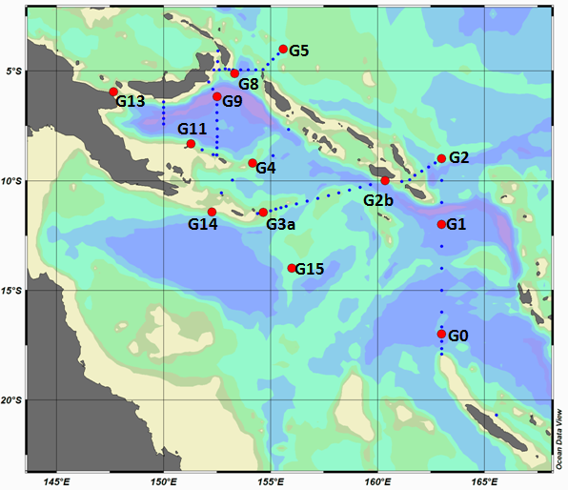

Décrire quels types de données sont nécessaires pour vous compléter votre propre jeu de données avant envoi à la base de données, et estimer le délai avant la disponibilité de vos données pour la base de données / Post-cruise data analysis/treatment required, and the time frame for this

To be completed by the PI

Estimations des erreurs, précision, sensibilité des données / Error estimates, precision and accuracy of the data

To be filled up when then measurements will be done

FICHIERS / FILES (that will be sent to the data bas

Nom de fichier de données / file name

To be filled up when then measurements will be done

Explication des têtes de colonne, des unités et des abréviations utilisées dans le fichier de données / data file structure

To be filled up when then measurements will be done

REFERENCES BIBLIOGRAPHIQUES

