FICHE META_INFORMATION_PARAMETRES
(à remplir par le responsable du paramètre) / (to be filled by the person in charge of the parameter)

PARAMETRES CONCERNES / Parameters

Name of the Parameter : BSi, LSi, particulate Al

OPERATION & CAMPAGNE & PIs / OPERATION & CAMPAIGN&PIs

Sampling method : CTD

Station number-Cast number and Operation code :

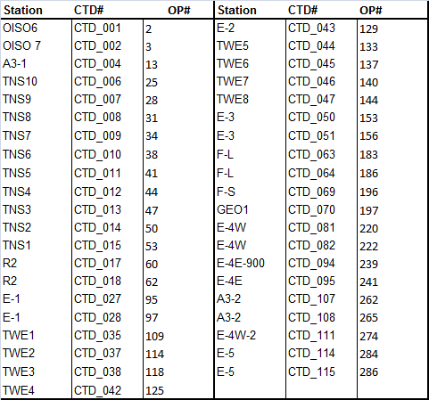

PROJET ETUDE / PROJECT TITLE

Campaign NAME : KEOPS2

Projetc Leader: Stéphane Blain (stephane.blain@obs-banyuls.fr)
Address : Laboratoire d'Océanographie Microbienne (LOMIC)
UMR 7621 CNRS UPMC
avenue du Fontaulé
66650 Banyuls sur mer
Chief Scientist: Bernard Queguiner (bernard.queguiner@univ-amu.fr)
Address : Institut Méditerranéen d'Océanographie
Université d'Aix-Marseille
UMR CNRS 7294/UR IRD 235
Campus de Luminy, case 901
F-13288 Marseille Cedex 09

RESPONSABLE SCIENTIFIQUE du paramètre / PI of the parameter
Nom /  name | adresse /  address | téléphone / phone number | fax /  fax number | adresse mél /  email address
LEBLANC  Karine | Institut Méditerranéen d'Océanographie  Université d'Aix-Marseille  UMR CNRS 7294/UR IRD 235  Campus de Luminy, case 901 F-13288 Marseille Cedex 09 | 0491829109 | 0491829540 | Karine.leblanc@univ-amu.fr

DESCRIPTION DES PARAMETRES / PARAMETERS DESCRIPTION

Ce qui a été collecté, mesuré et comment / How was the parameter collected and measured (include references for analytical methods)?

Sampling: 2 L seawater were sampled at each BIOGEO CTD cast and filtered onto 20 and 0,8 µm polycarbonate filters simultaneously. Samples were stored folded in 4 in eppendorf vials and dried overnight at 60°C. Closed eppendorfs were stored at room temperature.

Analytical procedure : (briefly, could be a short recall to a published reference):
Filters are analyzed for biogenic and lithogenic silica following the triple extraction procedure described in Ragueneau and al. (2005). Particulate aluminium is measured in parallel to correct for LSi contamination following fluorescence method with Lumogallion of Hydes and Liss (1976) and adapted by Howard and al. (1986).

Units: µmol L⁻¹

Décrire quels types de données sont nécessaires pour vous compléter votre propre jeu de données avant envoi à la base de données, et estimer le délai avant la disponibilité de vos données pour la base de données / Post-cruise data analysis/treatment required, and the time frame for this

Estimated Date of Delivery : March 2013

Estimations des erreurs, précision, sensibilité des données / Error estimates, precision and accuracy of the data

REFERENCES BIBLIOGRAPHIQUES

- Ragueneau, O., Savoye, N., Del Amo, Y., Cotten, J., Tardiveau, B., Leynaert, A. A new method for the measurement of biogenic silica in suspended matter of coastal waters : using Si :Al ratios to correct for the mineral interference. Continental Shelf Research, 25, 697-710
Howard, A.G., Coxhead, A.J., Potter, I.A., Watt, A.P. (1986). Determination of dissolved aluminium by the micelle-enhanced fluorescence of its lumogallion complex, Analyst, 111, 1379-1382.
- Hydes, D.J. and Liss, P.S. (1976) Fluorimetric method for the determination of low concentrations of dissolved aluminium in natural waters, Analyst, 101, 922-931.

