FICHE META_INFORMATION_PARAMETRES
(à remplir par le responsable du paramètre) / (to be filled by the person in charge of the parameter)

PARAMETRES CONCERNES / Parameters

Name of the Parameter : Phytoplankton pigments

OPERATION & CAMPAGNE & PIs / OPERATION & CAMPAIGN&PIs

Sampling method : High Performance Liquid Chromatography
Station number-Cast number : ISP 2, 4, 5, 6, 7, 8, 9, 10, 11, 12, 14, 15, 16
Operation code :

PROJET ETUDE / PROJECT TITLE

Campaign NAME : KEOPS2
Projetc Leader: Stéphane Blain (stephane.blain@obs-banyuls.fr)
Address : Laboratoire d'Océanographie Microbienne (LOMIC)
UMR 7621 CNRS UPMC
avenue du Fontaulé
66650 Banyuls sur mer
Chief Scientist: Bernard Queguiner (bernard.queguiner@univ-amu.fr)
Address : Institut Méditerranéen d'Océanographie
Université d'Aix-Marseille
UMR CNRS 7294/UR IRD 235
Campus de Luminy, case 901
F-13288 Marseille Cedex 09

RESPONSABLE SCIENTIFIQUE du paramètre / PI of the parameter
Nom /  name | adresse /  address | téléphone /  phone number | fax /  fax number | adresse mél /  email address
Hervé Claustre | CNRS – la Corderie- BP08 Quai de la Darse – 06238 Villefranche sur mer | 0493763729 | 0493763739 | claustre@obs-vlfr.fr
Josephine Ras | CNRS – la Corderie- BP08 Quai de la Darse – 06238 Villefranche sur mer | 0493763875 | 0493763739 | jras@obs-vlfr.fr

DESCRIPTION DES PARAMETRES / PARAMETERS DESCRIPTION

Ce qui a été collecté, mesuré et comment / How was the parameter collected and measured (include references for analytical methods)?

Sampling: 59 samples, corresponding to 13 vertical profiles, were collected from the in situ pumps.
1) A 53µm prefilter was used. The filter porosity was 1µm. The filtered volume was computed knowing the total filtered volume, the active filtered area (145.27 cm²) and the punched 25 mm filter area (4.9087 cm²).
3) The 25mm punched filters were stored in cryotubes and placed in liquid nitrogen. They were sent to Villefranche sur mer in dry shippers and stored in a -80°C freezer.

Analytical procedure : (briefly, could be a short recall to a published reference):
Extraction of the samples: in 100% methanol containing a Vitamin E acetate internal standard. Filters were disrupted by sonication. After 2 hours at -20°C, the extracts were clarified by filtration.
Extracts were injected into an Agilent Technologies 1200 series HPLC system. Separation took place within 28 minutes on a reversed phase Zorbax Eclipse XDB C8 column (3x150 mm; 3.5µm). The pigments were then detected by a diode array detector, at 4 detection wavelengths: 450nm (for carotenoids, chlorophylls c and b), 676nm (for Chlorophyll a and derived pigments), 770nm (for bacteriochlorophyll a) and 222nm (for internal standard).
Calibration of the HPLC system has been carried out with pigment standards from DHI Water and Environment (Denmark) and Sigma.
As part of the data validation phase, the Total Chla data have been compared with the CTD bottle fluorescence data.
The analytical procedure is described in more detail in Ras et al. (2008)

Units: mg.m-3

Décrire quels types de données sont nécessaires pour vous compléter votre propre jeu de données avant envoi à la base de données, et estimer le délai avant la disponibilité de vos données pour la base de données / Post-cruise data analysis/treatment required, and the time frame for this

Estimated Date of Delivery : delivered in May 2012 after comparison and completion with data from CTD bottle files.

Estimations des erreurs, précision, sensibilité des données / Error estimates, precision and accuracy of the data
Performance metrics :
Tchla injection precision : 0.2% |  | Calibration precision: 2.3%
Tchla accuracy (SeaHARRE-5): 0.84% |  | Calibration accuracy: 0.75%

The phytoplankton pigment database is described in the following table:

Table 1 : Pigment database line of titles, description, units, pigment detection wavelengths and limits of detection. LOD: Limits of detection (3 x Signal/Noise ratio).
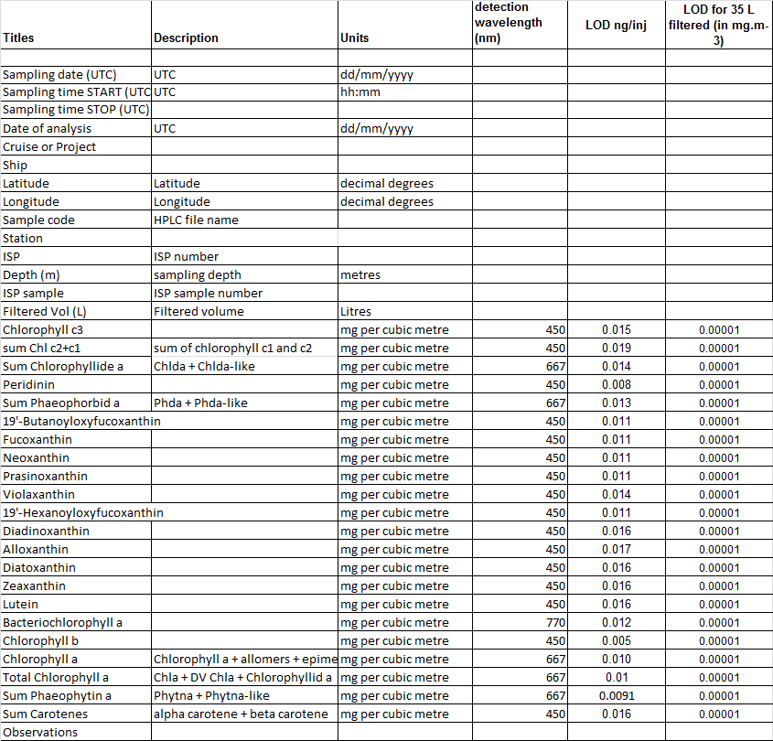
A “readme” file has been provided with the database. This comprises the above Table 1, a summary of the analytical procedure, the limits of detection for each measured pigment and a summary of the performance metrics of the method at the time of the analysis of the KEOPS2 samples.

REFERENCES BIBLIOGRAPHIQUES

Ras, J, Uitz, J, and H. Claustre (2008). Spatial variability of phytoplankton pigment distributions in the Subtropical South Pacific Ocean: comparison between in situ and modelled data. Biogeosciences, 5, 353-369.

