META_INFORMATION_PARAMETRES / PARAMETERS

(à remplir par le responsable du paramètre / to be filled by the PI )

Date de création | October 8, 2009 | created on
Date: de dernière mise à jour | Feb 12, 2019 | last update

PARAMETRES CONCERNES | PARAMETERS

Mode d’échantillonnage | No parametre | nom parametre | Status : [non] valid
Sampling | parameter number | name of the parameter | Status : [not] valid
Box corer/Incubation | 1 | Sediment oxygen demand
Box corer/ Miniincubation | 2 | Microfauna oxygen demand
Box corer | 3 | Sediment pigment concentration
Box corer | 4 | Sediment microbial abundance
Box corer | 5 | Bioturbation
Box corer/Incubation | 6 | Macrofaunal biomass
Box corer/Incubation | 7 | Water interface nitrate/nitrite, silicate, phosphate concentration changes
Box corer/Incubation | 8 | Water interface ammonium concentration changes
Box corer/Incubation | 9 | Water interface DOC concentration changes

PROJET ETUDE | PROJECT TITLE
Characterization of carbon turnover and remineralisation by benthic communities in relation to carbon input on the Mackenzie Shelf, Beaufort Sea, Canada

RESPONSABLE SCIENTIFIQUE | PRINCIPAL INVESTIGATOR

Nom /  Name | adresse /  address | téléphone / phone number | fax /  fax number | adresse mél /  email address
Philippe Archambault | Université de Laval, Département de biologie  Pavillon Alexandre-Vachon  1045, av. de la Médecine  Québec, Québec G1V 0A6  Canada | +1 418 656-2131 p. 405967 |  | philippe.archambault@bio.ulaval.ca
Gwenaelle Chaillou | Institut des sciences de la mer de Rimouski  Université du Québec à Rimouski  310 allée des Ursulines  Rimouski, Québec  G5L 3A1  Canada | +1 418-723-1986 p. 1950 |  | gwenaelle_chaillou@uqar.ca
Heike Link | University of Rostock Department Maritime Systems (MTS - INF)  Albert-Einstein-Str. 21  18059 Rostock  Germany | +49 381 498 p.8921 |  | Link.heike@gmail.com

BREVE DESCRIPTION DU PROJET | BRIEF DESCRIPTION OF PROJECT
- Test for benthic ecosystem functioning changes with modifications in resource availability (sedimented organic matter) in response to climate changes by field experiments
- Describe and compare the biodiversity (using a variety of diversity indices) secondary productivity of macrobenthic and meiobenthic communities in areas of enhanced and reduced productivity and diversity (‘hot-‘ and ‘coldspots’) in the Eastern Beaufort Sea

The first objective contributes to the goal to comparatively quantify major fluxes and pathways of carbon and nutrients at the seafloor, and to gain an additional measure of productivity for benthic communities. The measurements provide a bulk parameter, commonly termed the 'sediment oxygen demand' (SOD), integrating total aerobic respiration of the community of benthic organisms contained in the core. At the same time, changes in nutrient concentration for ammonia, nitrate, nitrite, silicate and phosphate in the ambient water are measured, to gain first knowledge on the role of benthic activity for the nutrient cycles in Arctic waters.

DESCRIPTION DES PARAMETRES | PARAMETERS DESCRIPTION

Ce qui a été mesuré et comment (méthode analytique et/ou références )/

What did you measure and how did you do it (include references for analytical methods)?
1 Sediment oxygen demand (SOD) (after Grant et al 2002)
- Oxygen concentration in the water phase overlying a sediment core (10 cm diameter, ca. 18 cm long) was measured at 3 – 6h intervals from 100 % until 80 % oxygen saturation
- Oxygen measurements with a Presens Fibox optical probe

2 Microfauna oxygen demand
- Oxygen measurements with a Presens Fibox optical probe in closed scintillation vials over the same period as general SOD

3 Sediment pigment concentration (after Riaux-Gobin et Klein 1993)
- fluorometrical analysis of Chl a and Phaeopigments per sediment weight and surface - at 1 cm intervals for 0 – 9 cm depth into the sediment

4 Sediment microbial abundance
- sediment samples were preserved in 2 % buffered and filtered formaldehyde solution and stored at -20 °C
- after suspension of bacteria in a liquid phase, bacterial abundance is analysed using a flow cytometer (following the method by Piot 2009, personal communication)

5 Bioturbation
- Bioturbation activity by endofauna over a 10 d incubation period at 4°C using luminophores (after Gilbert et al 2003)

6 Macrofaunal biomass
- total infauna abundance in sediment cores after sieving through a 500 µm mesh
- sieve residues were kept in 4 % formaldehyde in seawater solution

7 Water interface nitrate/nitrite, silicate, phosphate concentration changes
- concentration of nutrient in the water phase overlying the sediment core at ca. 100 %, 90 %, and 80 % oxygen concentration
- analysed onboard with Autoanalyser 3, Team Jean-Eric Tremblay (Johannie Martin, Jonathan Gagnon), adapted from Grasshoff (1999)

8 Water interface ammonium concentration changes
- concentration of nutrient in the water phase overlying the sediment core at ca. 100 %, 90 %, and 80 % oxygen concentration
- analysed onboard by the method adapted from Holmes et al (1999) with a Turner Design Fluorometer

9 Water interface DOC concentration changes
- concentration of DOC in the water phase overlying the sediment core at ca. 100 %, 90 %, and 80 % oxygen concentration
- samples were filtered through pre-combusted GF/F and stored as 2 replicates in each a 10 ml glass vial after acidification with 25 % phosphoric acid
- samples will be analyzed by the Bruno Charriere, Villefrance, France (wet oxidation method)

Stratégie d'échantillonnage /

Sampling strategy

Benthic boundary fluxes (parameters 1,2,7,8,9) and their determining factors (parameters 3-6) were sampled from sediment cores over a depth gradient along the Mackenzie Delta runoff and at sites, where vertical organic matter fluxes were determined. Several sites were chosen in overlap with other cruises to allow seasonal and interannual comparability of the data.

Décrire quels types de données sont nécessaires pour vous compléter votre propre jeu de données avant envoi à la base de données, et estimer le délai avant la disponibilité de vos données pour la base de données /

Post-cruise data analysis/treatment required, and the time frame for this

by summer 2010:
- Sediment pigment concentration (Chl a and phaeopigments) (analyses in the home lab) (parameter 3)
- corrected benthic carbon turnover (parameters 1,2)
- corrected ammonium fluxes (parameter 8)
- corrected nutrient fluxes (parameter 7)

by fall 2010
- microbial abundance (parameter 4)
- corrected DOC fluxes (parameter 9, depending on Bruno Charriere)

after fall 2010
- macrofaunal diversity and biomass (parameter 6)
- bioturbation rates (parameter 5)

Estimations des erreurs, précision, sensibilité des données /

Error estimates, precision and accuracy of the data
……………

FICHIERS | FILES

Nom de fichier de données /

File name

Explication des têtes de colonne, des unités et des abréviations utilisées dans le fichier de données /

Data file structure, units, label columns, …

RESULTATS PRELIMINAIRES | RESULTS
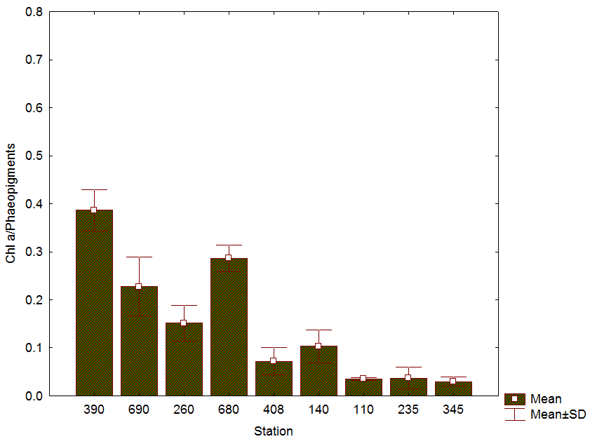
Fig. 1: Ratio of Chl a vs phaeopigments in surface sediments (0 – 1 cm) of sampled stations during the Malina cruise 2009 (parameter 3); depth increases from left to right.
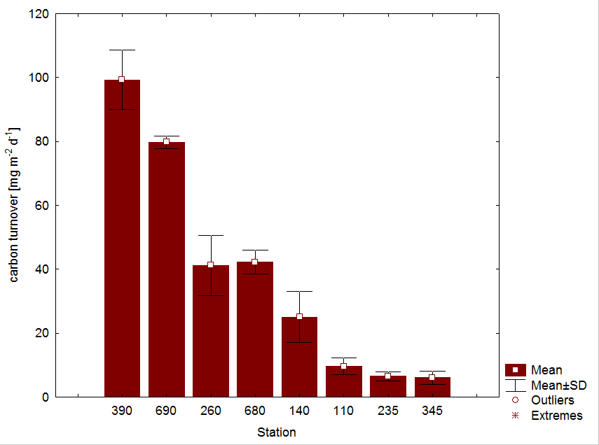
Fig. 2: Carbon turnover by benthic communities determined from incubation experiments (parameter 1) at stations sampled during the Malina cruise 2009; depth increases from left to right.
PRELIMINARY DATA

REFERENCES BIBLIOGRAPHIQUES | REFERENCES - PAPERS
Gilbert F, Hulth S, Strömberg N, Ringdahl K, Poggiale JC (2003) 2-D optical quantification of particle reworking activities in marine surface sediments. Journal of Experimental Marine Biology and Ecology 285–286: 251– 263

Grant J, Hargrave B, MacPherson P (2002) Sediment properties and benthic-pelagic coupling in the North Water. Deep-Sea Research Part II-Topical Studies in Oceanography 49:5259-5275

Grasshoff K, Methods of seawater analyses, Weinheim, New-York, 600 p., 1999.

Holmes RM, Aminot A, Kerouel R, Hooker BA, Peterson BJ (1999) A simple and precise method for measuring ammonium in marine and freshwater ecosystems. Canadian Journal of Fisheries and Aquatic Sciences 56:1801-1808

Riaux-Gobin C, Klein B (1993) Microphytobenthic Biomass Measurement Using HPLC and Conventional Pigment Analysis. In: Kemp P, Sherr B, Sherr E, Cole J (eds) Handbook of methods in aquatic microbial ecology. Lewis Publishers, Boca Raton, p 369-376

