FICHE META_INFORMATION_PARAMETRES
(à remplir par le responsable du paramètre)

Nom du DATASET / Data SET NAME

Data set Name (list of the measured parameters):
Name:
IOP – Hyperspectral and multispectral inherent optical properties (IOP) data acquisition along 0 – 200 m profiles (200 m maximum, some profiles are shallower).

Measured Parameters:
200 m depth profiles of:
- Hyperspectral attenuation and absorption coefficients (resp. “c” and “a”), between 400 and 740 nm approximately (every 3.5 nm approximately),
- Mutlispectral scattering coefficients at 124 degrees (“b”) at 412, 440, 488, 510, 532, 595, 650, 676, 700, 715, 720, 770 and 870 nm,
- Conductivity, temperature and pressure,
- Coloured Dissolved Organic Matter (CDOM) fluorescence,
- Chlorophyll-a fluorescence,
- Scattering coefficient at 650 nm, in 32 angles (these data are not processed yet, coming later!).

See the html file “GE.Optics.IOP.report.html” for detailed explanations.

Exhaustive list of the provided parameters:
All the following parameters are provided along a 0.25 m depth grid, and are cleaned for spikes / outliers (with a +/- 25 points running median), then smoothed with a local regression algorithm (“loess”):
- Attenuation and absorption coefficients, interpolated every 5 nm,
- Particulate backscattering coefficients at 412, 440, 488, 510, 532, 595, 650, 676, 700, 715, 720, 770 and 870 nm,
- Salinity,
- Temperature,
- Chlorophyll-a concentration,
- CDOM concentration.

PROJET-ETUDE / PROJECT TITLE

Campaign NAME: GreenEdge – ICECAMP – 2016
Date begin: 04 May
Date end: 29 June
Chief Scientist: Marcel Babin
Address:
Université Laval
UMI Takuvik
1045 avenue de la médecine
Québec, QC, G1V0A6, Canada

OPERATION (if Relevant)

Sampling method:
All the sensors mentioned above are installed on a stainless steel frame. They are all connected to a unique data logger, which power them on and synchronizes their respective measurements. With the help of a motorized pulley, the frame is lowered in the hole located in the polarhaven, at a regular descent rate of approximately 1 m/s.
The data acquisition is meant to be performed on the downward part of the profiles, as several sensors are installed at the bottom of the frame. Indeed, when the frame is retrieved from its maximum depth, even if the ascent rate is low, water is dragged in the frame’s wake, so that the data recorded by the bottom-of-frame sensors might be biased, or offset. But even though, data were still recorded during the upward parts of the profiles, as few sensors are not affected to the same extent by this error. The more affected sensors are especially the particulate scattering meters (“bbp”), the chl-a and CDOM fluorescence-meters. The less affected ones are the AC-S meter (“a” and “c”), as well as the CTD (both pumping water on the top of the frame).

Station number-Cast number: see section 5

Operation code: IOP

RESPONSABLE SCIENTIFIQUE du paramètre / PI of the parameter

Nom /  name | adresse /  address | téléphone / phone number | fax /  fax number | adresse mél /  email address
Guislain BECU | Takuvik | 656-2131 x 8567 | 656-2339 | Guislain.Becu@takuvik.ulaval.ca

DATASET contact
Nom /  name | adresse /  address | téléphone / phone number | fax /  fax number | adresse mél /  email address

idem resp. scientifique.

INFORMATION GEOGRAPHIQUES / GEOGRAPHIC INFORMATION

Predefined site (if relevant): inside of the polarhaven

Location: inside the polarhaven

LATITUDE: 67.48 N

LONGITUDE: 063.79 W

The data acquisition has been performed as per the table below. See also the field log file (“LOG.GE2016.ICMP.IOP.short.csv”) that is available from the data base.

dateUTC | timeUTC | doy | lat | lon | filename | cast_type
16-05-03 | 19:30 | 124 | 063.79 W | 67.48 N | 2016124.d01_IOP.txt | downcast
16-05-03 | 19:39 | 124 | 063.79 W | 67.48 N | 2016124.u01_IOP.txt | upcast
16-05-04 | 19:10 | 125 | 063.79 W | 67.48 N | 2016125.d01_IOP.txt | downcast
16-05-04 | 19:39 | 125 | 063.79 W | 67.48 N | 2016125.u01_IOP.txt | upcast
16-05-04 | 20:20 | 125 | 063.79 W | 67.48 N | 2016125.d02_IOP.txt | downcast
16-05-04 | 20:32 | 125 | 063.79 W | 67.48 N | 2016125.u02_IOP.txt | upcast
16-05-06 | 18:50 | 127 | 063.79 W | 67.48 N | 2016127.d01_IOP.txt | downcast
16-05-06 | 19:07 | 127 | 063.79 W | 67.48 N | 2016127.u01_IOP.txt | upcast
16-05-09 | 18:29 | 130 | 063.79 W | 67.48 N | 2016130.d01_IOP.txt | downcast
16-05-09 | 18:50 | 130 | 063.79 W | 67.48 N | 2016130.u01_IOP.txt | upcast
16-05-11 | 17:55 | 132 | 063.79 W | 67.48 N | 2016132.d01_IOP.txt | downcast
16-05-11 | 18:05 | 132 | 063.79 W | 67.48 N | 2016132.u01_IOP.txt | upcast
16-05-13 | 19:08 | 134 | 063.79 W | 67.48 N | 2016134.d01_IOP.txt | downcast
16-05-13 | 19:25 | 134 | 063.79 W | 67.48 N | 2016134.u01_IOP.txt | upcast
16-05-14 | 19:30 | 135 | 063.79 W | 67.48 N | 2016135.d01_IOP.txt | downcast
16-05-16 | 17:38 | 137 | 063.79 W | 67.48 N | 2016137.d01_IOP.txt | downcast
16-05-16 | 17:55 | 137 | 063.79 W | 67.48 N | 2016137.u01_IOP.txt | upcast
16-05-18 | 17:10 | 139 | 063.79 W | 67.48 N | 2016139.d01_IOP.txt | downcast
16-05-18 | 17:30 | 139 | 063.79 W | 67.48 N | 2016139.u01_IOP.txt | upcast
16-05-20 | 18:22 | 141 | 063.79 W | 67.48 N | 2016141.d01_IOP.txt | downcast
16-05-20 | 18:50 | 141 | 063.79 W | 67.48 N | 2016141.u01_IOP.txt | upcast
16-05-23 | 17:30 | 144 | 063.79 W | 67.48 N | 2016144.d01_IOP.txt | downcast
16-05-23 | 17:45 | 144 | 063.79 W | 67.48 N | 2016144.u01_IOP.txt | upcast
16-05-23 | 17:30 | 144 | 063.79 W | 67.48 N | 2016144.d01_IOP.txt | downcast
16-05-23 | 17:45 | 144 | 063.79 W | 67.48 N | 2016144.u01_IOP.txt | upcast
16-05-25 | 15:40 | 146 | 063.79 W | 67.48 N | 2016146.d01_IOP.txt | downcast
16-05-25 | 16:10 | 146 | 063.79 W | 67.48 N | 2016146.u01_IOP.txt | upcast
16-05-27 | 18:46 | 148 | 063.79 W | 67.48 N | 2016148.d01_IOP.txt | downcast
16-05-27 | 19:40 | 148 | 063.79 W | 67.48 N | 2016148.u01_IOP.txt | upcast
16-05-30 | 17:50 | 151 | 063.79 W | 67.48 N | 2016151.d01_IOP.txt | downcast
16-05-30 | 18:10 | 151 | 063.79 W | 67.48 N | 2016151.u01_IOP.txt | upcast
16-06-01 | 17:55 | 153 | 063.79 W | 67.48 N | 2016153.d01_IOP.txt | downcast
16-06-01 | 18:05 | 153 | 063.79 W | 67.48 N | 2016153.u01_IOP.txt | upcast
16-06-03 | 18:30 | 155 | 063.79 W | 67.48 N | 2016155.d01_IOP.txt | downcast
16-06-03 | 18:50 | 155 | 063.79 W | 67.48 N | 2016155.u01_IOP.txt | upcast
16-06-03 | 19:00 | 155 | 063.79 W | 67.48 N | 2016155.d02_IOP.txt | downcast
16-06-03 | 19:25 | 155 | 063.79 W | 67.48 N | 2016155.u02_IOP.txt | upcast
16-06-06 | 17:32 | 158 | 063.79 W | 67.48 N | 2016158.d01_IOP.txt | upcast
16-06-06 | 17:32 | 158 | 063.79 W | 67.48 N | 2016158.u01_IOP.txt | upcast
16-06-06 | 17:50 | 158 | 063.79 W | 67.48 N | 2016158.u02_IOP.txt | upcast
16-06-06 | 17:55 | 158 | 063.79 W | 67.48 N | 2016158.u03_IOP.txt | upcast
16-06-06 | 18:00 | 158 | 063.79 W | 67.48 N | 2016158.u04_IOP.txt | upcast
16-06-08 | 18:19 | 160 | 063.79 W | 67.48 N | 2016160.d01_IOP.txt | downcast
16-06-08 | 18:32 | 160 | 063.79 W | 67.48 N | 2016160.d02_IOP.txt | downcast
16-06-08 | 18:36 | 160 | 063.79 W | 67.48 N | 2016160.u01_IOP.txt | upcast
16-06-10 | 18:58 | 162 | 063.79 W | 67.48 N | 2016162.d01_IOP.txt | downcast
16-06-10 | 19:26 | 162 | 063.79 W | 67.48 N | 2016162.u01_IOP.txt | upcast
16-06-10 | 19:38 | 162 | 063.79 W | 67.48 N | 2016162.d02_IOP.txt | downcast
16-06-10 | 19:58 | 162 | 063.79 W | 67.48 N | 2016162.u02_IOP.txt | upcast
16-06-11 | 16:37 | 163 | 063.79 W | 67.48 N | 2016163.d01_IOP.txt | downcast
16-06-11 | 16:46 | 163 | 063.79 W | 67.48 N | 2016163.u01_IOP.txt | upcast
16-06-13 | 18:18 | 165 | 063.79 W | 67.48 N | 2016165.d01_IOP.txt | downcast
16-06-13 | 18:37 | 165 | 063.79 W | 67.48 N | 2016165.u01_IOP.txt | upcast
16-06-13 | 18:37 | 165 | 063.79 W | 67.48 N | 2016165.d02_IOP.txt | downcast
16-06-13 | 18:50 | 165 | 063.79 W | 67.48 N | 2016165.u02_IOP.txt | upcast
16-06-15 | 18:18 | 167 | 063.79 W | 67.48 N | 2016167.d01_IOP.txt | downcast
16-06-15 | 18:37 | 167 | 063.79 W | 67.48 N | 2016167.u01_IOP.txt | upcast
16-06-15 | 18:43 | 167 | 063.79 W | 67.48 N | 2016167.d02_IOP.txt | downcast
16-06-15 | 18:47 | 167 | 063.79 W | 67.48 N | 2016167.u02_IOP.txt | upcast
16-06-17 | 18:35 | 169 | 063.79 W | 67.48 N | 2016169.d01_IOP.txt | downcast
16-06-17 | 18:54 | 169 | 063.79 W | 67.48 N | 2016169.u01_IOP.txt | upcast
16-06-17 | 18:58 | 169 | 063.79 W | 67.48 N | 2016169.d02_IOP.txt | downcast
16-06-17 | 19:02 | 169 | 063.79 W | 67.48 N | 2016169.u02_IOP.txt | upcast
16-06-19 | 19:05 | 172 | 063.79 W | 67.48 N | 2016172.d01_IOP.txt | downcast
16-06-19 | 19:25 | 172 | 063.79 W | 67.48 N | 2016172.u01_IOP.txt | upcast
16-06-19 | 19:36 | 172 | 063.79 W | 67.48 N | 2016172.d02_IOP.txt | downcast
16-06-19 | 19:43 | 172 | 063.79 W | 67.48 N | 2016172.u02_IOP.txt | upcast
16-06-22 | 18:25 | 174 | 063.79 W | 67.48 N | 2016174.d01_IOP.txt | downcast
16-06-22 | 18:44 | 174 | 063.79 W | 67.48 N | 2016174.u01_IOP.txt | upcast
16-06-22 | 18:51 | 174 | 063.79 W | 67.48 N | 2016174.d02_IOP.txt | downcast
16-06-22 | 18:59 | 174 | 063.79 W | 67.48 N | 2016174.u02_IOP.txt | upcast
16-06-24 | 17:40 | 176 | 063.79 W | 67.48 N | 2016176.d01_IOP.txt | downcast
16-06-24 | 18:01 | 176 | 063.79 W | 67.48 N | 2016176.u01_IOP.txt | upcast
16-06-24 | 18:07 | 176 | 063.79 W | 67.48 N | 2016176.d02_IOP.txt | downcast
16-06-24 | 18:14 | 176 | 063.79 W | 67.48 N | 2016176.u02_IOP.txt | upcast
16-06-24 | 18:17 | 176 | 063.79 W | 67.48 N | 2016176.u03_IOP.txt | upcast
16-06-27 | 14:35 | 178 | 063.79 W | 67.48 N | 2016179.d01_IOP.txt | downcast
16-06-27 | 14:41 | 178 | 063.79 W | 67.48 N | 2016179.u01_IOP.txt | upcast
16-06-27 | 19:00 | 178 | 063.79 W | 67.48 N | 2016179.d02_IOP.txt | downcast
16-06-27 | 19:18 | 178 | 063.79 W | 67.48 N | 2016179.u02_IOP.txt | upcast
16-06-29 | 18:39 | 181 | 063.79 W | 67.48 N | 2016181.d01_IOP.txt | downcast
16-06-29 | 18:55 | 181 | 063.79 W | 67.48 N | 2016181.u01_IOP.txt | upcast

DESCRIPTION DES INSTRUMENTS / INSTRUMENTS DESCRIPTION (if Relevant)

Instrument Type:
- CTD,
- Active optics meters including attenuation meter, absorption meter, scattering meter, particle size distribution meter and fluorescence meter.

Model:
- Pumped FastCat 49 CTD,
- AC-S meter,
- ECO (triplet) meters,
- LISST (laser scattering based measurements of particles size distribution).

Manufacturer:
- Seabird Scientific / WETLabs (AC-S & ECO meters),
- Seabird Scientific / Seabird Electronics (CTD),
- Sequoia Scientific (LISST).

Instrument Features / Calibration:
Factory calibrated in December 2015. The LISST and AC-S sensors are known to be fast-drifting ones, so that in-field pure water calibrations (“offsets”) were performed nearly every single sampling day.

DESCRIPTION DES PARAMETRES / PARAMETERS DESCRIPTION

Ce qui a été collecté, mesuré et comment / How was the parameter collected and measured (include references for analytical methods)?

Sampling: vertical profiles, recording on downcast (optimum) and on upcast (sub-optimum).

Analytical procedure: (briefly, could be a short recall to a published reference): A factory provided software allows for the pre-processing of almost all the files, which includes application of the factory calibration coefficients for example, or temperature corrections. Lab-written routines are then used to clean the data, to smooth the profiles (using a Loess local regression), apply additional corrections, as well as to compute an averaged profile per day. Again, see the “GE.Optics.IOP.report.html” for detailed explanations.

Units:
Absorption, attenuation, particle back-scattering coefficients are provided in m⁻¹,
Chl-a concentration is given in mg.m⁻³,
CDOM concentration is given in p.p.b.,
Temperature is given in Celsius degrees,
Salinity is given in p.s.u.

See the html file “GE.Optics.IOP.report.html” for detailed explanations.

Sensor Precision: see below from the factory spec. sheet for the following instruments:

ECO meters (b_{bp} at 700nm, Fl-Chla, Fl-CDOM):
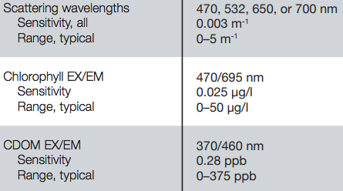

ECO meter (b_{bp} at 412, 440, 488, 510, 532, 595, 650, 676 and 715 nm):
(720, 770 and 870 nm are similar to 715 nm)
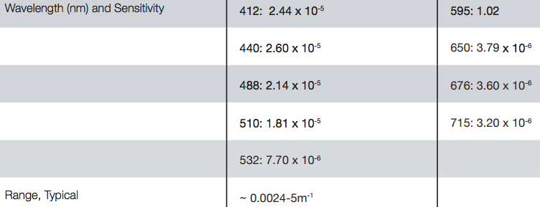

CTD (temperature and salinity)
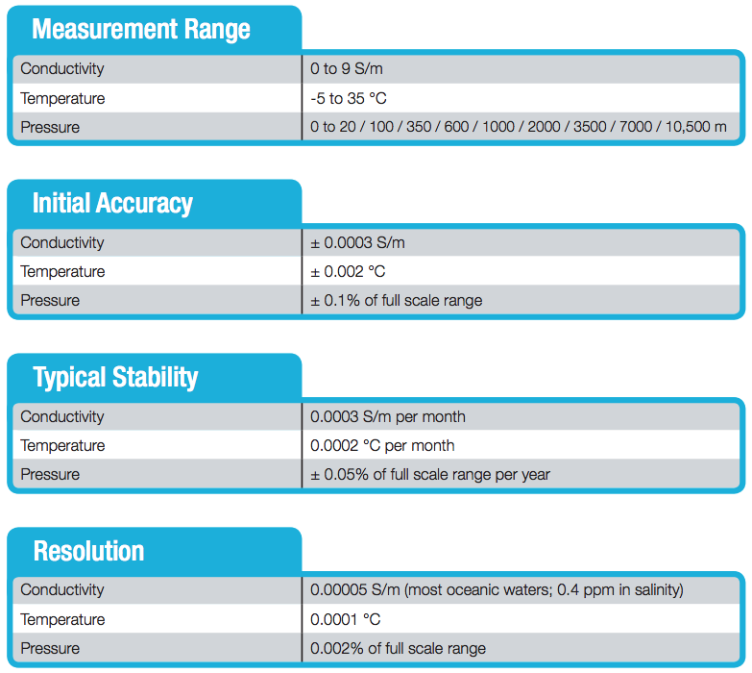

AC-S meter (absorption and attenuation coefficients)
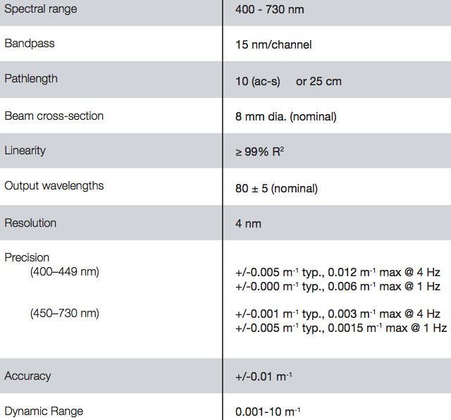

Décrire quels types de données sont nécessaires pour vous compléter votre propre jeu de données avant envoi à la base de données, et estimer le délai avant la disponibilité de vos données pour la base de données / Post-cruise data analysis/treatment required, and the time frame for this

Estimated Date of Delivery: Winter 2017/2018.

REFERENCES BIBLIOGRAPHIQUES

See the html file “GE.Optics.IOP.report.html” for detailed explanations.

