Report on the utilization of the MVP200 during the OUTPACE cruise
(February/April 2015)
Lucio Bellomo, Gilles Rougier

1. Long-Duration Stations
LD-A (lon: 164.688, lat:-19.213) - 24/02 @ 11h UTC → 03/03 @ 11h UTC
We have performed:

Operation | Description | Sensors | Comments
Cross | Regular cross, 3 transects,  40 km x 40 km square | CTD*,** + fluo + LOPC | - Unexploitable Salinity (S)  - Attention to the quality of Temperature (T) measurements, due to the partially “hidden” position of the sensor
MVP_before | Slightly smaller zigzag,  7 transects instead of 8,  20 km x <20 km square | CTD** + fluo + LOPC | Same as for Cross
MVP_after | Regular zigzag, 8 transects,  20 km x 20 km | SVPT*** + fluo + LOPC | Unexploitable T and S
* Broken Conductivity sensor (Fig. 1)
** Placed in the back of the fish (Fig. 2 shows the SVPT, but the position of the CTD is the same) so that
the T sensor is only partially in the free flow of water (it is “shaded” by the metallic structure of the
fish)
*** Placed in the back of the fish (Fig. 2), where T and D sensors are completely not in the free flow of
water

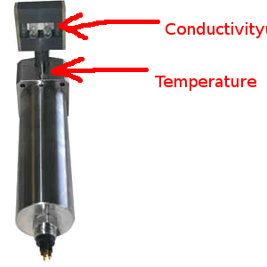Fig. 1: AML microCTD with the position of the Conductivity (C) and Temperature (T) sensors
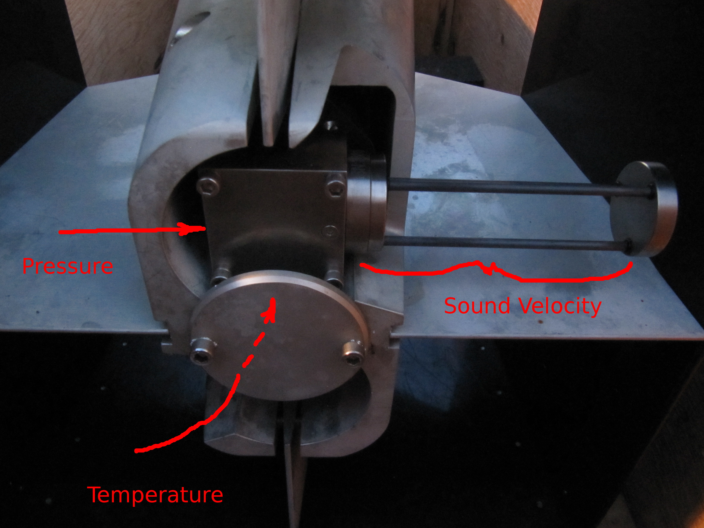Fig. 2: Initial location of the Valeport SVPT, giving very bad measurements due to the "hidden" position of the Pressure (P) and Temperature (T) sensors
LD-B (lon: 189.142, lat: -18.24) - 12/03 @ 10h UTC → 21/03 @ 09h UTC
We have first changed the position of the Valeport SVPT. It has been put, thanks to a metallic tool built by the mariners onboard, in the middle of the fish, outside the protective plastic “wings”, to have it in the water flow without obstacles (Fig. 4). We have then performed:

Operation | Description | Sensors | Comments
Cross | Not at all a cross!  3 long transects (Fig. 3) | SVPT* + fluo + LOPC | - Acceptable S, but still very noisy and a little underestimated wrt the Rosette's CTD
MVP_before | Slightly smaller zigzag,  7 transects instead of 8,  20 km x <20 km square | SVPT* + fluo + LOPC | Same as for Cross
MVP_after | Just 1 long transect in-out of the chrlophyll-a patch | SVPT* + fluo + LOPC | Same as for Cross
* Placed in the middle of the fish, our new position, where measurements should be clean as the sensors are
well in the water flow (see Fig. 4)

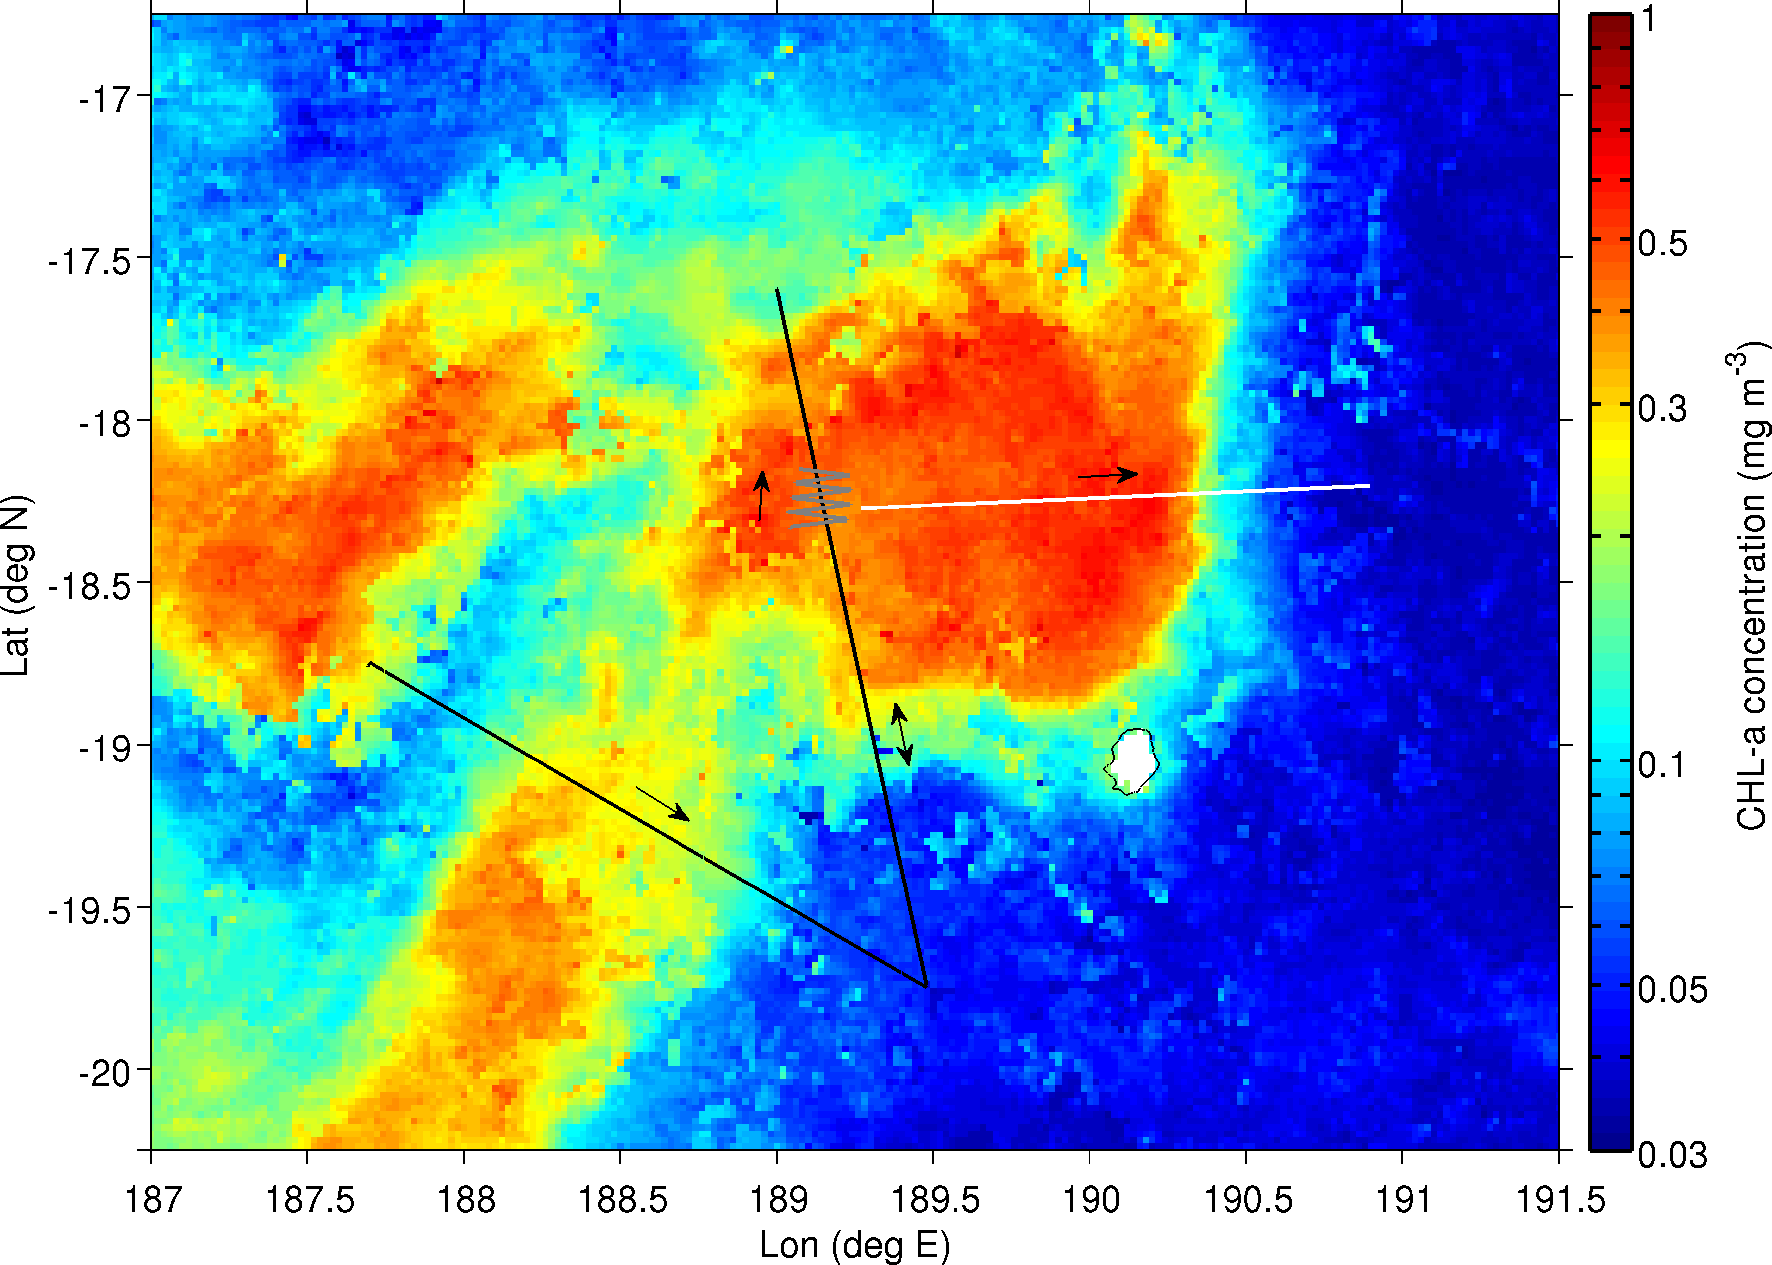Fig. 3: Average Chlorophyll-a concentration (CLS data) with MVP track. (Black) Cross, (gray) MVP_before, (white) MVP_after
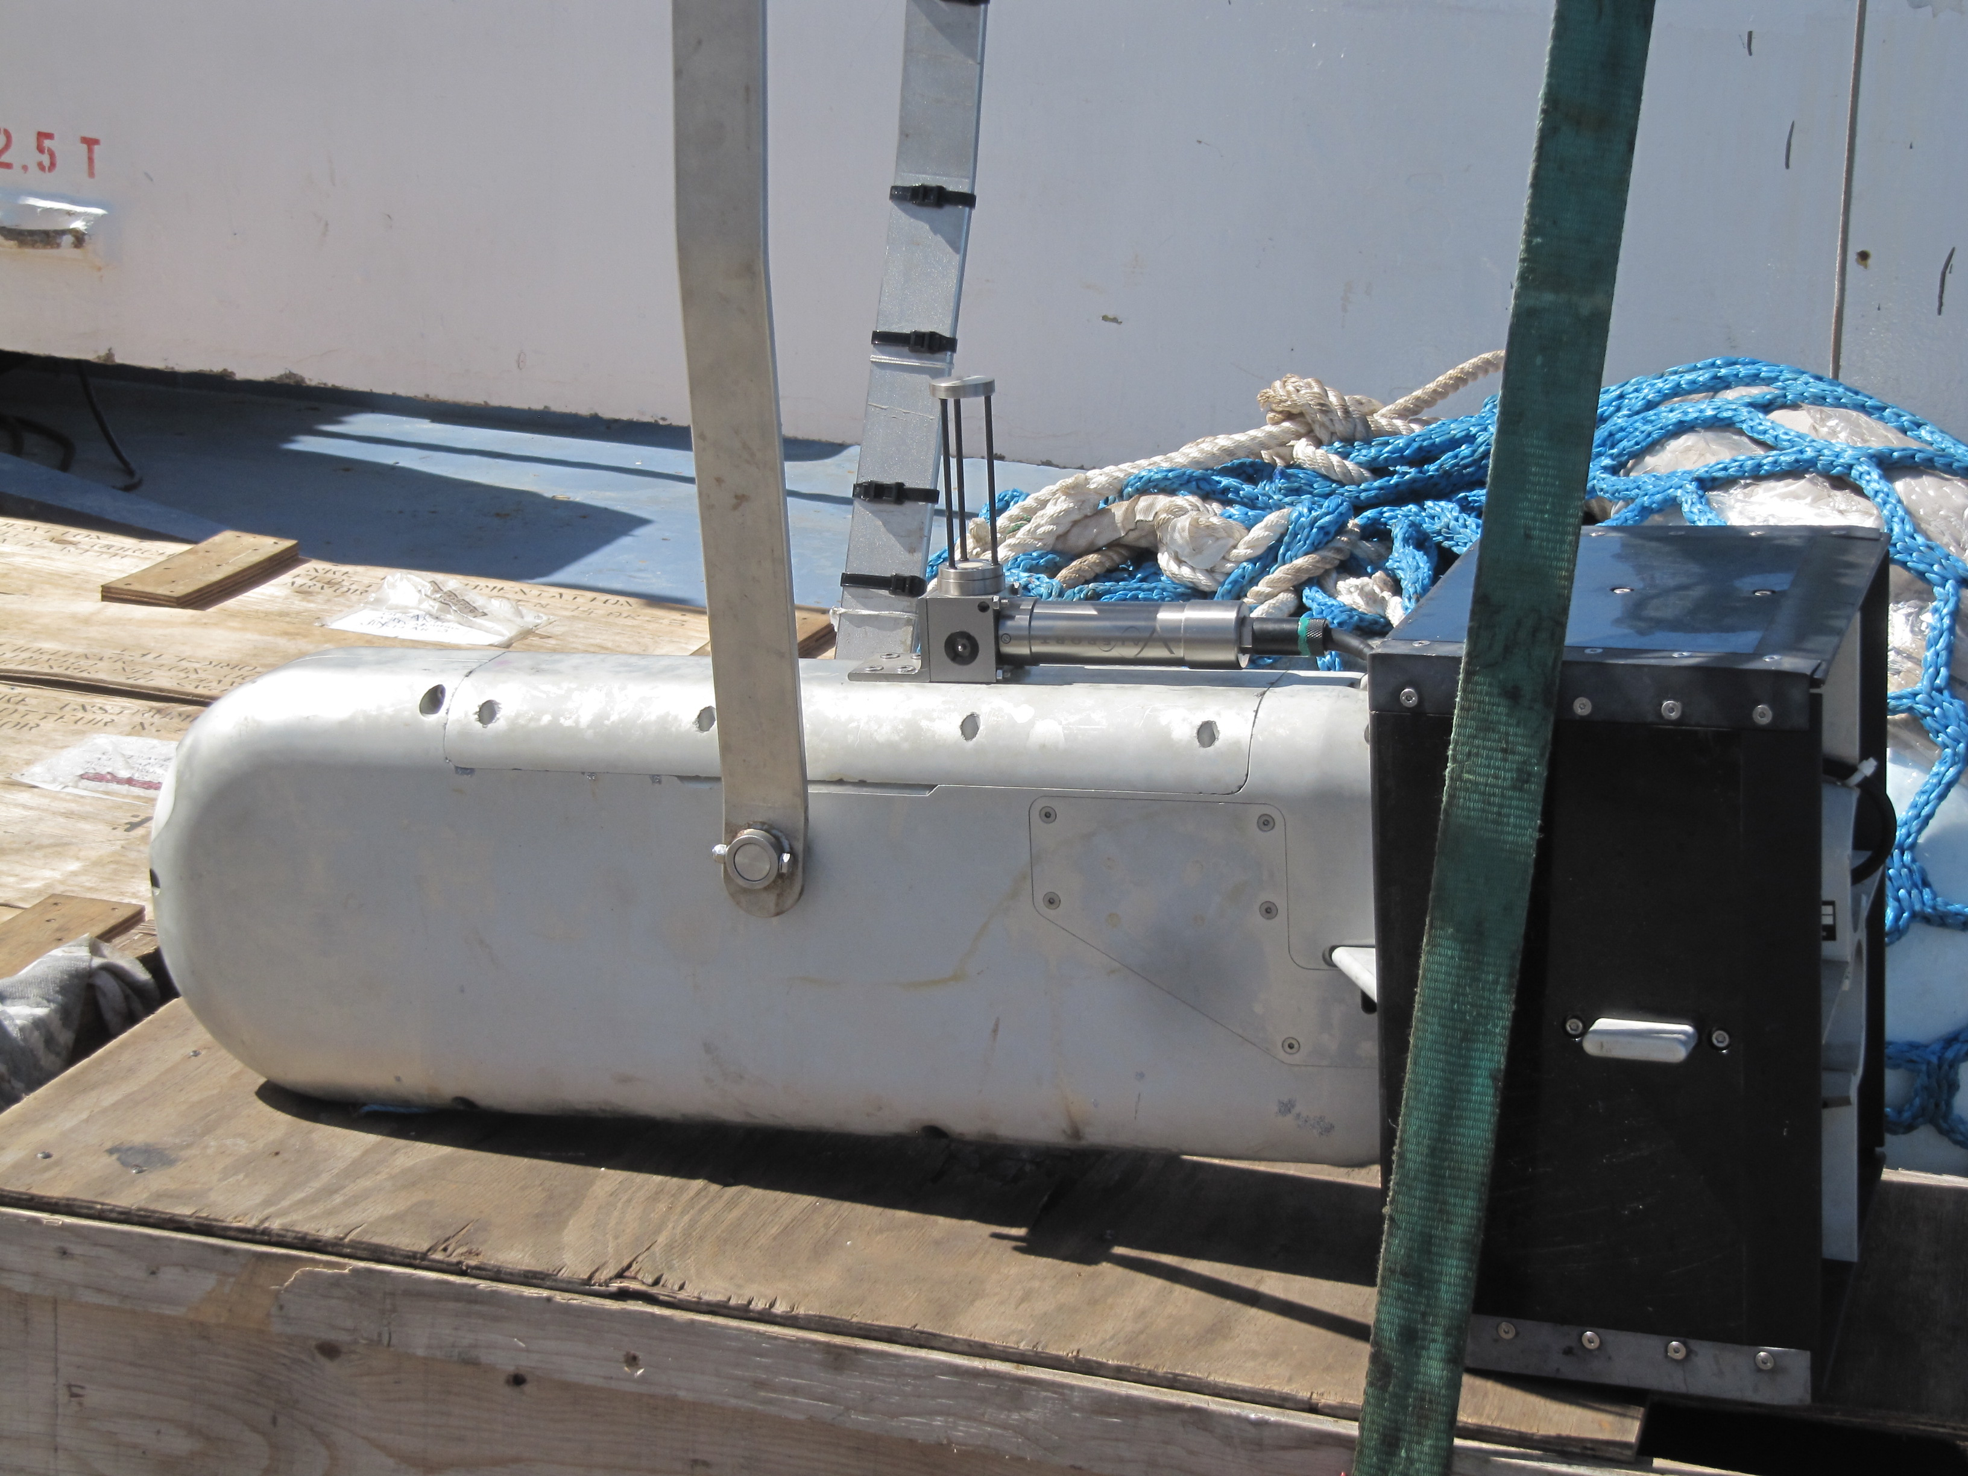Fig. 4: New "home-made" position of the Valeport SVPT in the middle of the fish, fully in the water flow.
LD-C (lon: 194.06, lat: -18.42) – 22/03 @ 22h UTC → 29/03 @ 09h UTC
Only the Cross has been performed here. Almost at the end of it (we were lucky), the MVP stopped working because of a thick bend along the cable (see Fig. 5) that prevented the downcast to be performed until the end (Max Cable Out or Max Depth). There was no time for the MVP_before anyway, but the MVP_after was replaced by an “old-style”, almost North-South, CTD transect (CTD_after).

Operation | Description | Sensors | Comments
Cross | Regular cross, 3 transects,  40 km x 40 km square | SVPT* + fluo + LOPC | - Acceptable S, but still very noisy and a little underestimated wrt the Rosette's CTD
CTD_after | Just 1 long transect with 7 classic Rosette CTD's | All Rosette's sensors | CTD 200, 201, …, 206
* Placed in the middle of the fish, our new position, where measurements should be clean as the sensors are
well in the water flow (see Fig. 4)

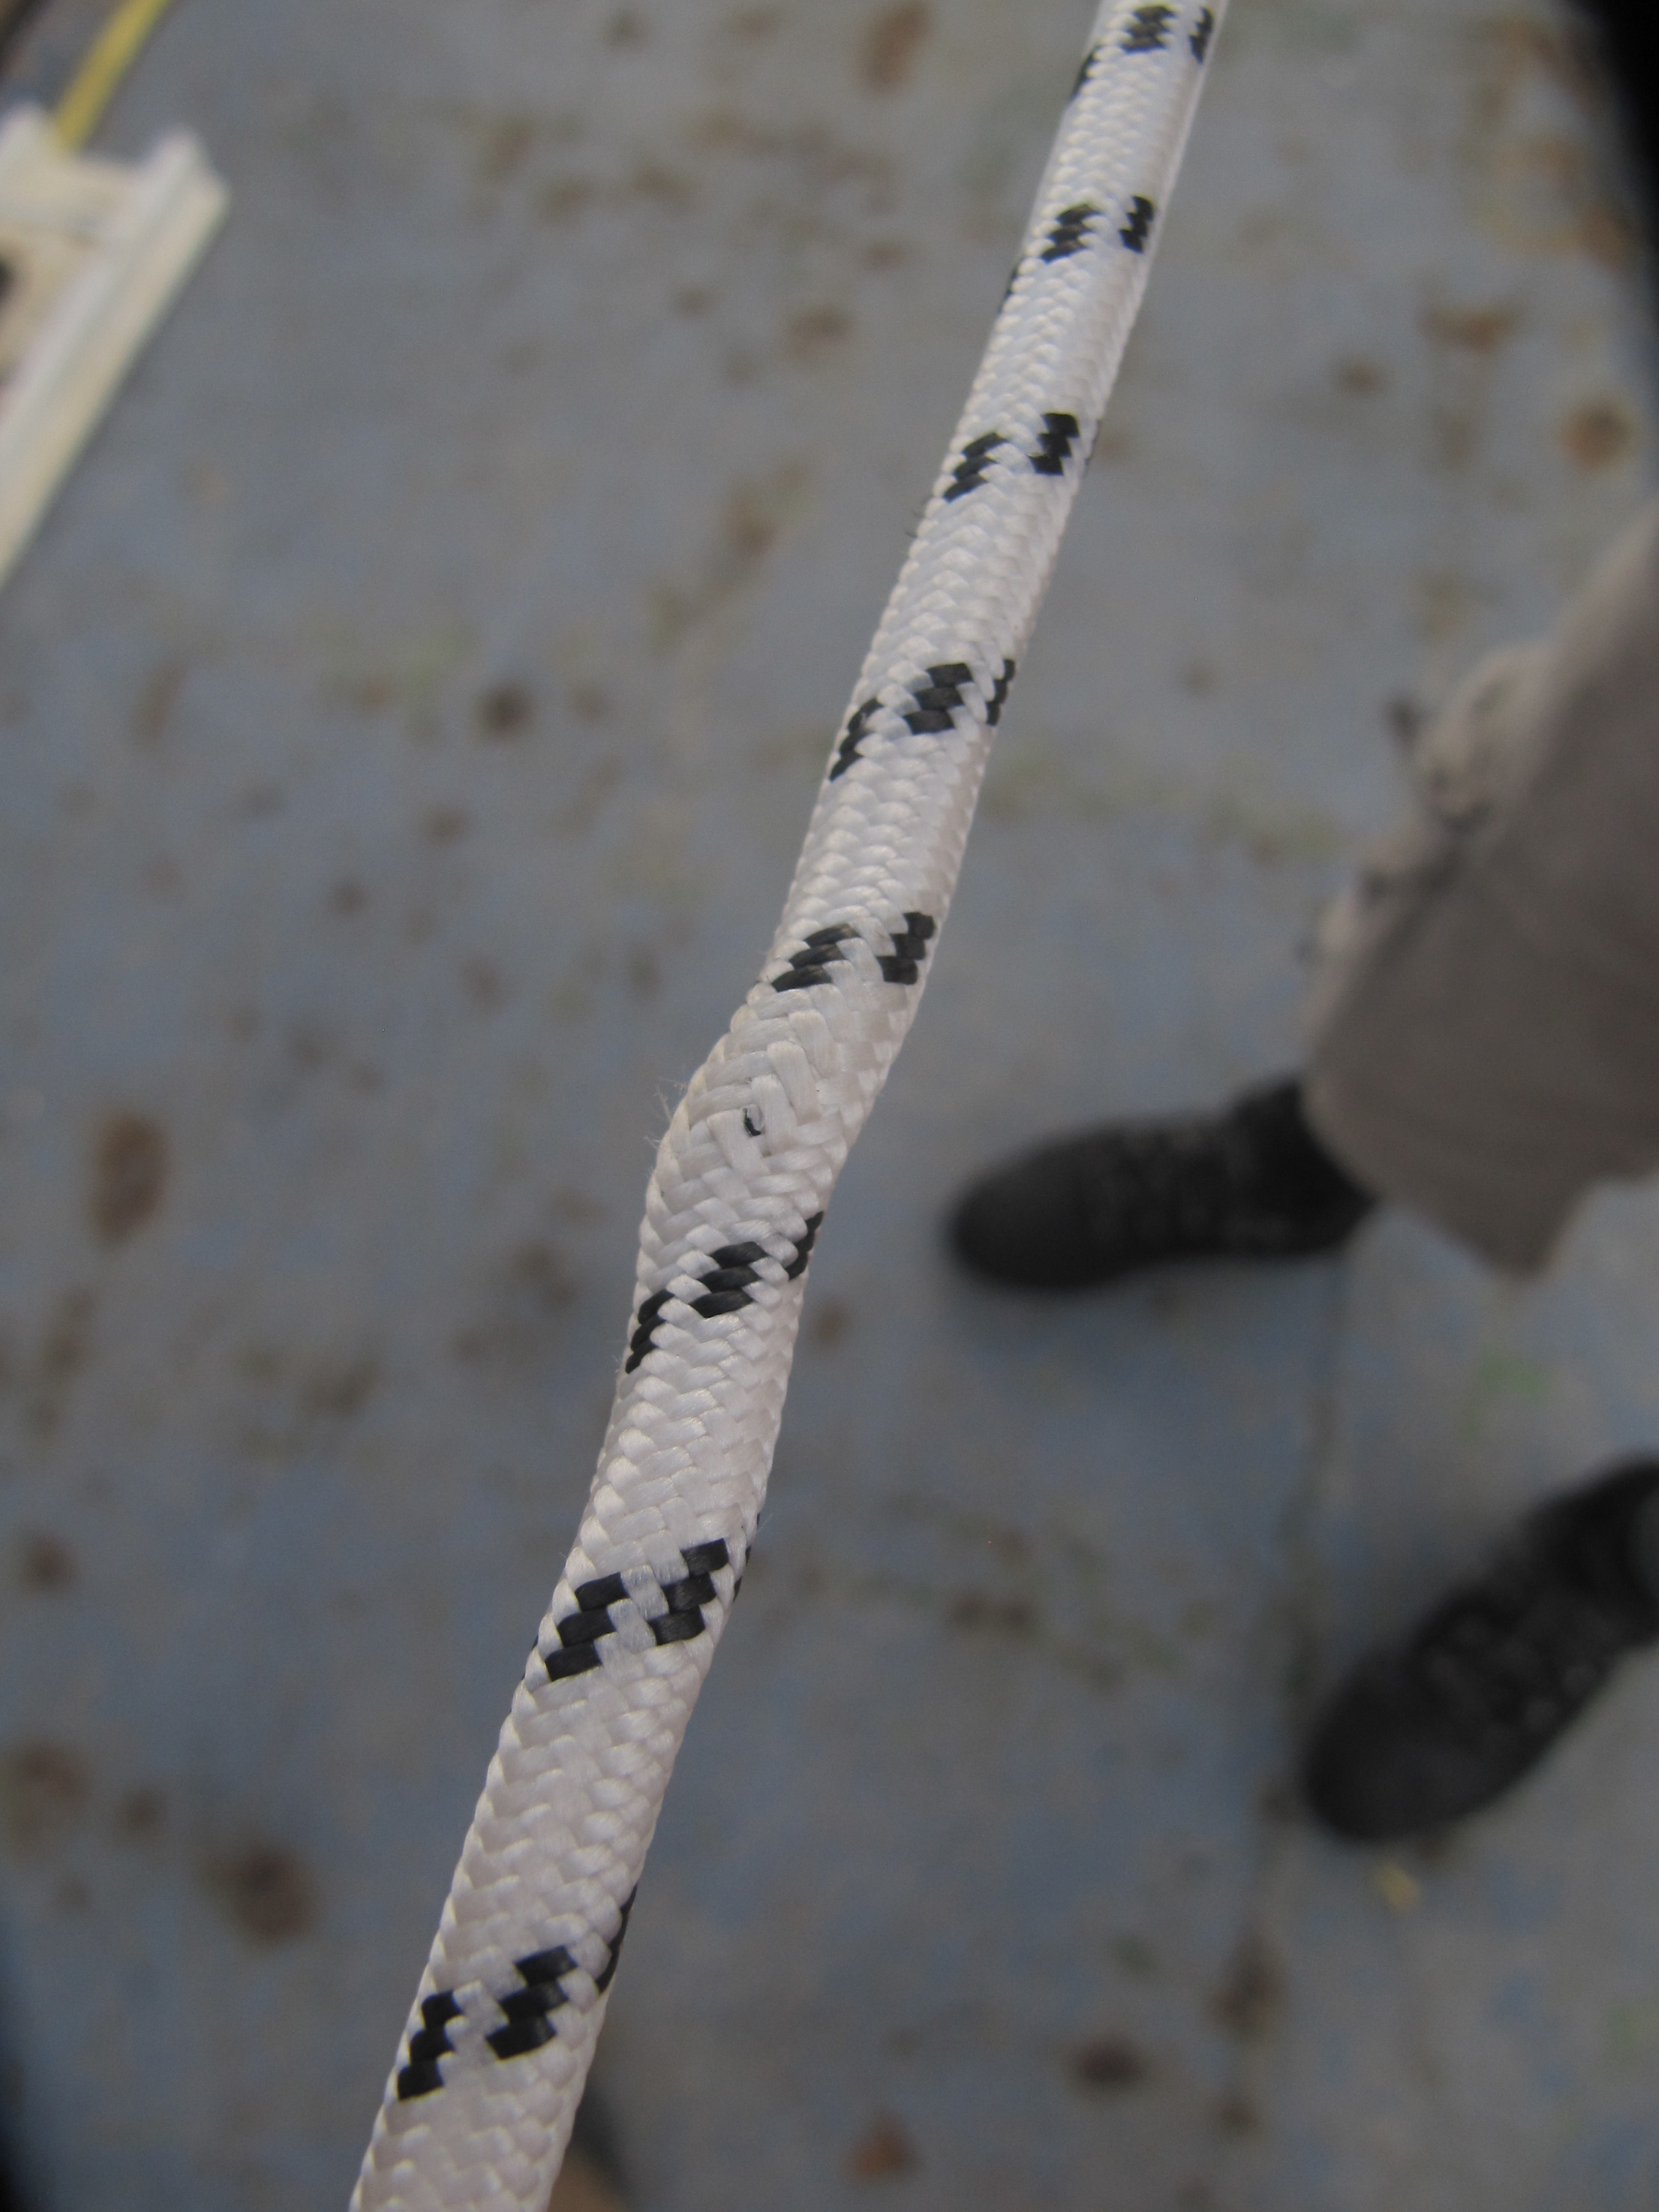Fig. 5: Cable bending causing the MVP to interrupt its downcasts

2. Post-calibration tests
Test  # | MVP file(s) | MVP  configuration | MVP  comments | CTD file(s) | CTD  comment | Other instr's file(s) | Other comment
1 | 2015-02-25  _111401 | AML uCTD  with broken C | Last zigzag profile (MVP_before) | out_c_021 | Made right after the MVP
2 | 2015-02-26  _094058 | AML uCTD  with broken C | Station mode,  vertVel = 1 m/s | out_c_030 | Made right after the MVP
3 | 2015-02-27  _115523  _121226  _123429 | AML uCTD  with broken C | Station mode,  1 < vertVel < 2 m/s | out_c_037 | Made right after the MVP | RBRprofile_3 | RBR attached to the back of the fish
4 | 2015-03-02  _080328  _081950  _084304 | SVPT, bad position  (rear of the fish) | Station mode,  vertVel = 1 m/s | out_c_063 | Made right before the MVP
5 | 2015-03-06  _230819  _231503  _233357  _234039  _234729  _235418  2015-03-07  _000114 | SVPT, “home-made” position | Zigzag mode,  made on purpose | out_c_080 | Made right after the MVP
6 | 2015-03-08  _061050 | SVPT, “home-made” position | Station mode,  vertVel = 1 m/s | out_c_087 | Made right before the MVP | VMP_profile_6 | VMP profile made right after the MVP
7 | 2015-03-14  _225233  2015-03-15  _003131 | SVPT, “home-made” position | During zigzag  (MVP_before) | out_c_104 | Made at one of the  edges of MVP_before

